1. Download Solr from link - https://archive.apache.org/dist/lucene/solr/8.7.0/
2. unzip the file
3. Now set the Environment Variable for java.
4. Search for "Edit the system environment variables" in windows search bar

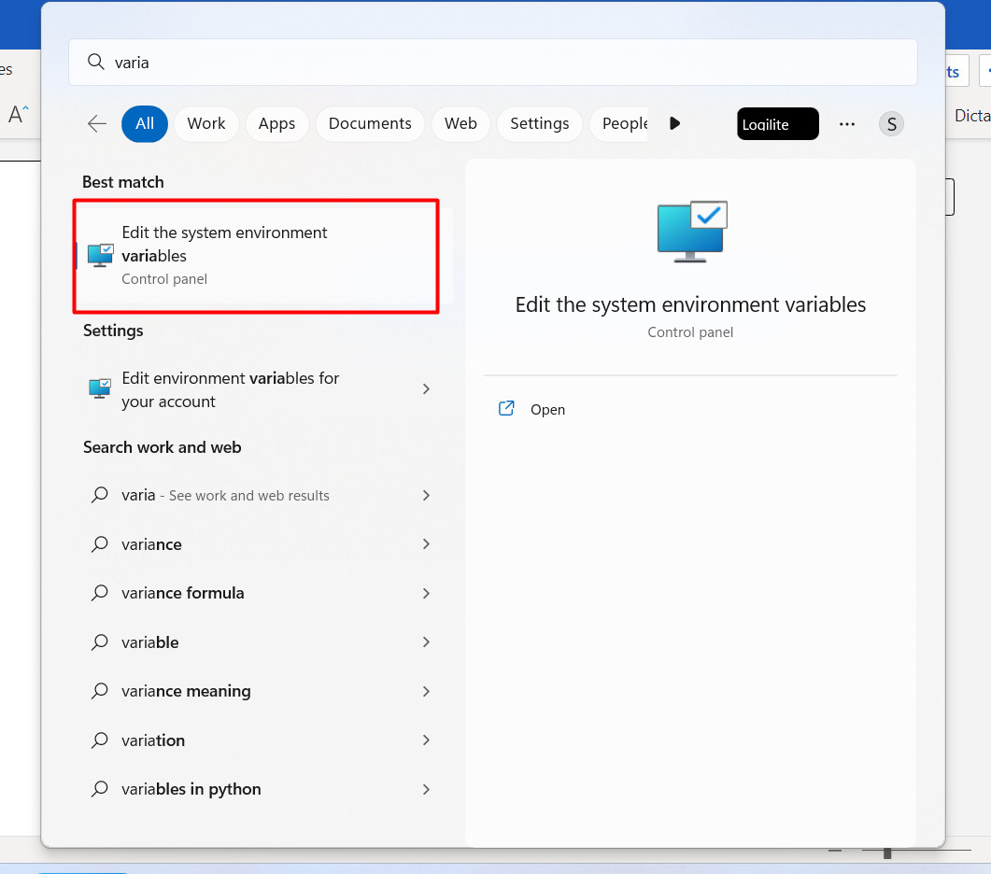

1. Now Copy Java path & paste it in “user variable” & “system variable”

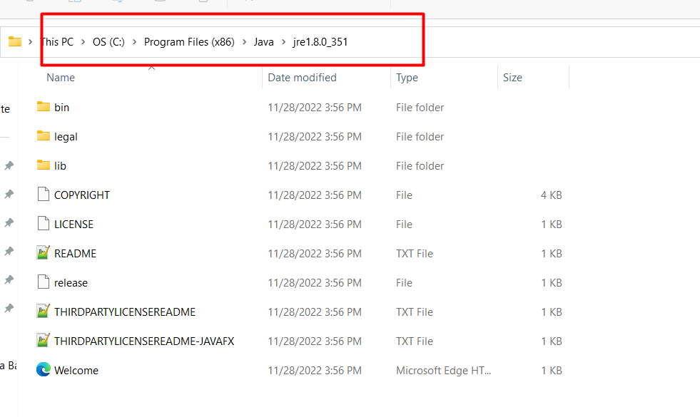

6) Set Environment Variable JAVA_HOME with above path

- Click on new & set it for both “user variable” & “system variable”

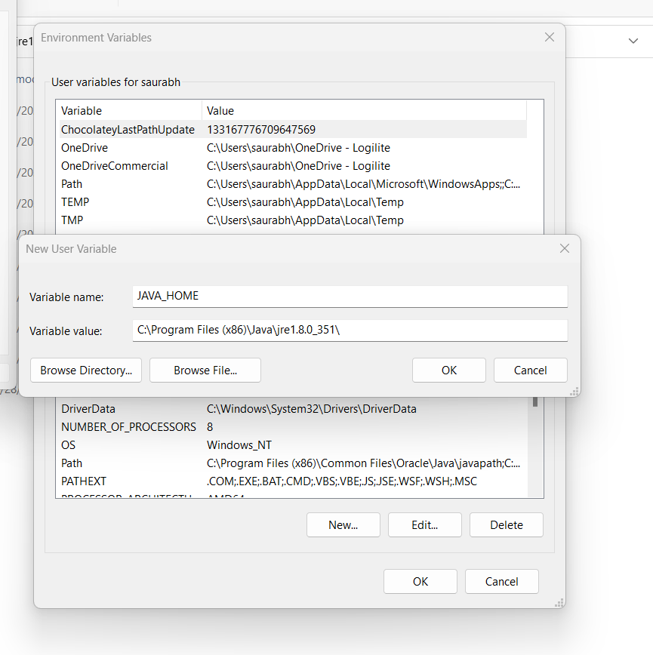

7) verify in cmd by typing java --version

8) Now run cmd as administrator & go to your solr path

cd D:\solr-8.7.0\bin

solr start

9) Now add core

Solr create_core –c < CoreName > -d _default   
  
